EXHIBITION SPACE RENTAL

To be returned to Hande Yilmaz by email hyilmaz@estro.org

All booking procedure will start on:
20 October 2020 for ESTRO Gold Corporate members
27 October 2020 for ESTRO Corporate members
12 November 2020 for the whole industry

Please complete in capital letters. ESTRO cannot be responsible for mistakes resulting for illegible handwriting.

COMPANY DETAILS

Company name
Invoicing address
Contact person
VAT number (if applies)
Purchase order number - PO (if applies)
Tel
E-mail …………………………....
Company website ………………………....

COMPANY DETAILS TO BE PUBLISHED IN THE CONFERENCE PROGRAMME BOOK
(if different from above, please complete)

Company name
Company Address
Contact person
Tel …………………………....
E-mail …………………………....
This application is legally binding for the exhibitor pending its acceptance in writing by the organiser.

By signing this application form, you declare that you have read and accepted the ESTRO Rules and Regulations.

Name: Title:

Signature: Date:

BOOKING OF FLOOR SPACE ONLY

Price per square meter: 500 € (excl. VAT)

Space requirement: ................. Front x .................. Depth – (Minimum size is 9 sqm)

We prefer the following booth locations: 1st .................. 2nd .................. 3rd..................

Gold & Corporate members can send their location preference by highlighting the areas in the floorplan below (until 3 November):
https://www.estro.org/getmedia/cb8c01fd-fc44-4b0c-9111-d2621eb06c64/ESTRO-2021_18082020.jpg.aspx

-Please make sure to send at least 3 location preferences as we cannot guarantee the availability of your first preference.

-Please make sure to include any specific booth design preference you have such as an island booth, corner booth etc.

-Feel free to provide us some tips regarding your neighbour booth preferences.
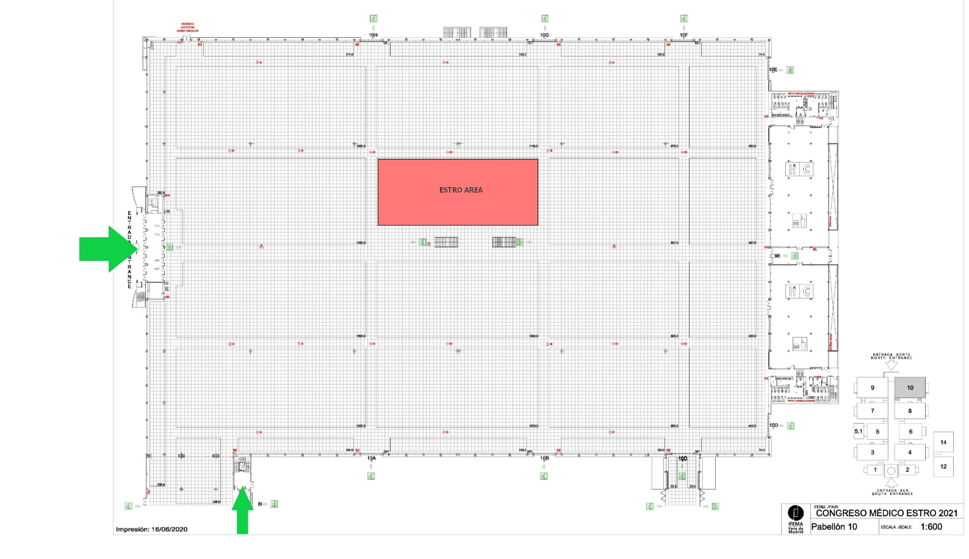

BOOKING OF FLOOR SPACE+MODULAR SHELL SCHEME

Price per square: 600 € (excl. VAT)

The modular shell scheme offered by the organizer includes:
- White modular bilaminated panels with natural aluminum frame h.250cm
- Dark grey carpet tiles
- Fascia board with company name
- Booth number (paper)
- 1 LED spotlights on electric rail per 4 sqm
- 1 triple socket
- 1,1kW main power connection
- Basic cleaning
- Structural build-up + dismantling

NOT included in the modular shell scheme:
- Furniture
- Additional exhibitor orders
- Internet access
- Daily cleaning

We prefer the following booth locations: 1st .................. 2nd .................. 3rd..................

Gold & Corporate members can send their location preference by highlighting the areas in the floorplan below (until 3 November):
https://www.estro.org/getmedia/cb8c01fd-fc44-4b0c-9111-d2621eb06c64/ESTRO-2021_18082020.jpg.aspx

-Please make sure to send at least 3 location preferences as we cannot guarantee the availability of your first preference.

-Please make sure to include any specific booth design preference you have such as an island booth, corner booth etc.

-Feel free to provide us some tips regarding your neighbour booth preferences.
